Word Problem Solving Strategy
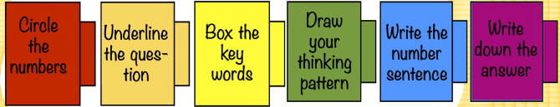
1. Jack had 19 balls. Jill had 38 balls. What’s the total number of balls Jack and Jill had?
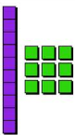 + =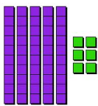
Jack Jill
19+38=57
Jack and Jill had 57 balls in total. (Or the total number of balls Jack and Jill had is 57.)

