**Unit 3 : Time and Money**

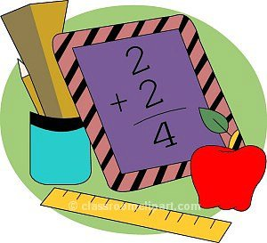

**2nd grade**

**Caesar Rodney School District**

***Unit Vocabulary :***

AM/a.m. analog clock

cent digital clock

dime dollar

hour hour hand

minute minute hand

money nickel

penny PM/p.m.

quarter set

time value

***Unit Summary :***

In this unit, students will work on telling time to the nearest 5 minutes and working with money. Analog and digital clocks should be used to read and write times. (Samples of each have been added to this letter.) Students will also gain an understanding of a.m. and p.m. and how it effects time. Our students will also be working with coins (pennies, nickels, dimes, and quarters) in mixed sets and should be able to identify coins and their values. As students are writing money amounts, please encourage them to use the $ and ¢ symbols correctly. They will also apply their knowledge of money to solve word problems.

***Essential Skills:***

* Telling time to the nearest whole and half hour.
* Telling time to the nearest 5 minutes.
* Understand the difference between a.m. and p.m.
* Identify coins and their value.
* Count mixed sets of coins.
* Solve word problems involving money

***What can I do at home to help?***

* Practice reading clocks throughout the day
* Have your child make a schedule of tasks to complete
* Give your child small sets of coins to practice counting.
* Have your child separate and sort a pile of coins. Set out four bowls, and then place a penny, nickel, dime, or quarter in front of each bowl. Then count the total in each bowl.
* Practice skip counting by 5s with nickels and 10s with dimes and on an analog clock

***Books to Read*** *:*

* Pigs Will Be Pigs: Fun with Math and Money, by Amy Axelrod
* The Penny Pot by Stuart Murphy
* Alexander, Who Used to Be Rich Last Sunday by Judith Voirst
* Benny’s Pennies by Pat Brisson
* The Clock Struck One by Trudy Harris
* Its About Time by Stuart Murphy
* A Second is a Hiccup by Hazel Hutchins

***Additional Resources :***

* Telling Time game : <http://kinderwebgames.com/clock_01.html>
* Time Keeper game : <http://www.fuelthebrain.com/Interactives/app.php?ID=296>
* Stop the Clock : <http://www.bgfl.org/custom/resources_ftp/client_ftp/ks2/maths/time/index.htm>
* Bank It! : <http://www.fuelthebrain.com/Interactives/app.php?ID=40>
* Money Flashcards : <http://www.aplusmath.com/cgi-bin/flashcards/money>

***Money and Time tools***

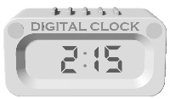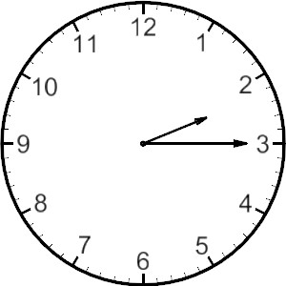

*Digital time Analog time*

